2018+ (JL/JLU/JLR/JLUR) Jeep Wrangler

Yeti XD Rear Track Bar

Installation Instructions

!IMPORTANT INFORMATION!
IT IS THE OWNER’S RESPONSIBILITY TO HAVE ALL NUTS AND BOLTS CHECKED FOR TIGHTNESS AFTER THE FIRST 100 MILES AND THEN EVERY 3,000 MILES. WHEEL ALIGNMENT, STEERING SYSTEM AND SUSPENSION SYSTEMS MUST BE INSPECTED AND ALL COMPONENTS GREASED BY A QUALIFIED PROFESSIONAL MECHANIC EVERY 3,000 MILES OR AFTER OFF-ROAD USE.

Track Bar Part Number:

Tool List:

- 15mm open end wrench or deep well socket
- 21mm open end wrench
- 21mm socket w/ ratcheting wrench
- Torque Wrench to fit 15mm and 21mm sockets
- Floor Jack

Installation Steps

- Using your 21mm socket/wrench, remove the driver and passenger side rear track bar bolts
  - 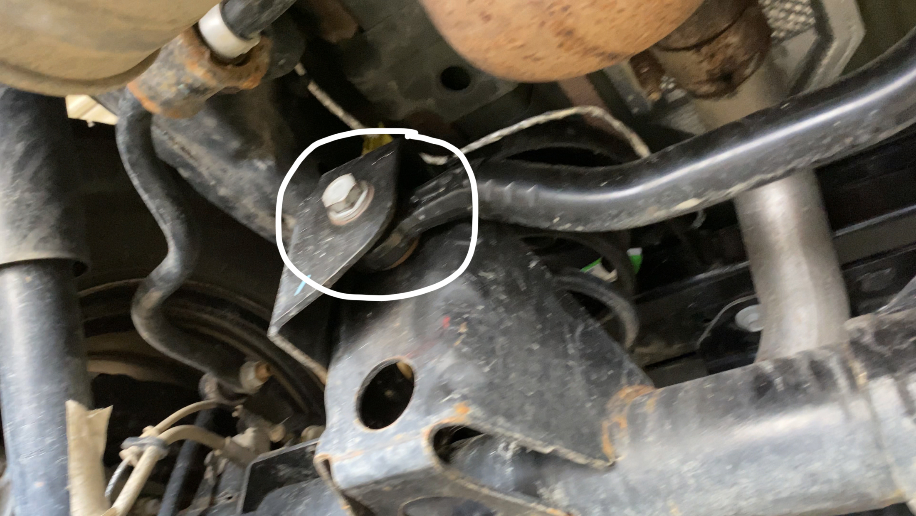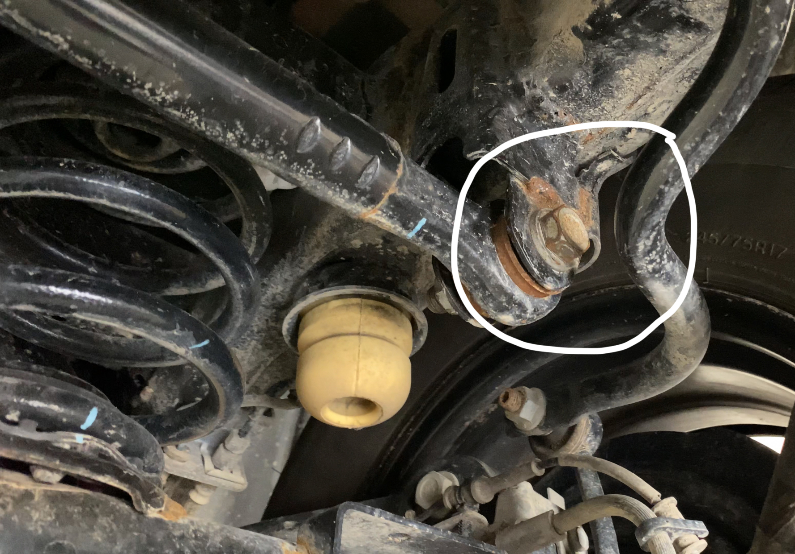
  - Note – you will need to slightly lift the passenger side rear to gain access to the bolt to remove.
  - Once removed, keep bolt and nut as they will be reused to install the Yeti XD Rear Track Bar 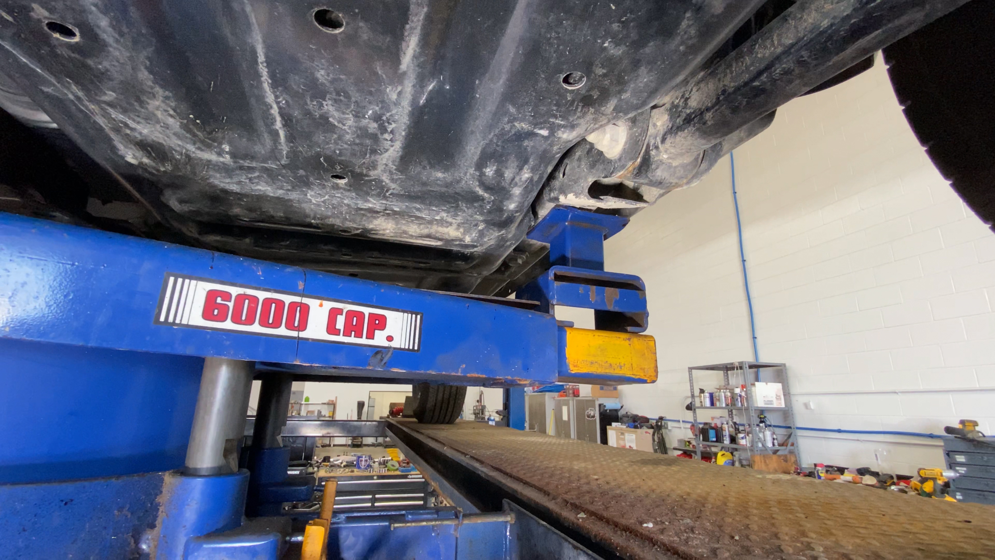
- Remove the bolts and then remove the track bar from the rear of the vehicle
- It is now time to assemble the Yeti XD Rear Track Bar.
  - If your vehicle is stock height, you will measure and match the length of the stock track bar
  - If you are installing with a lift, you will need to adjust the length of the track bar to your required length
  - 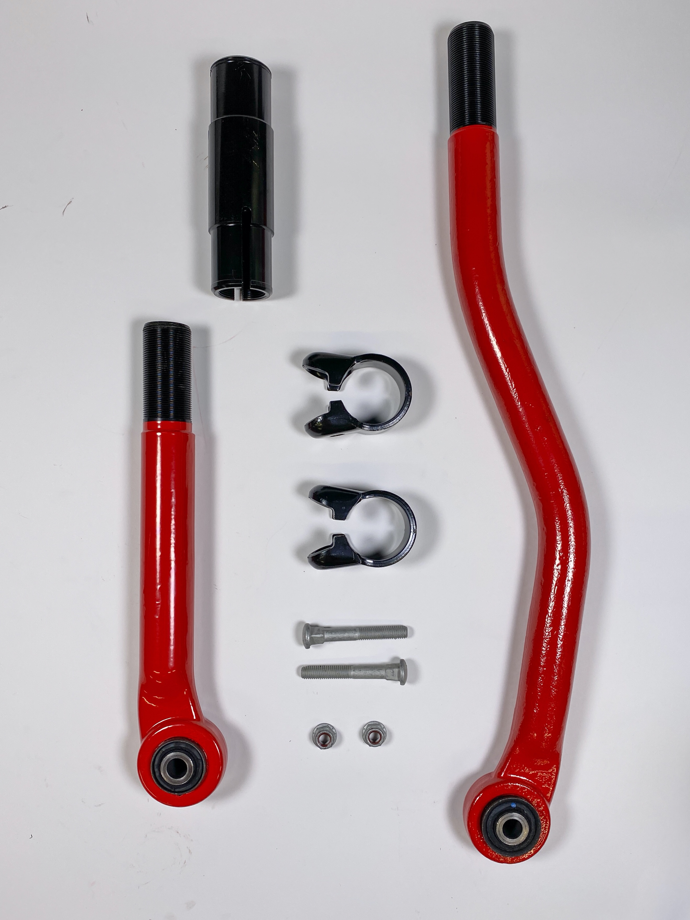
  - First Step – put fasteners through the clamps and lightly twist on the nuts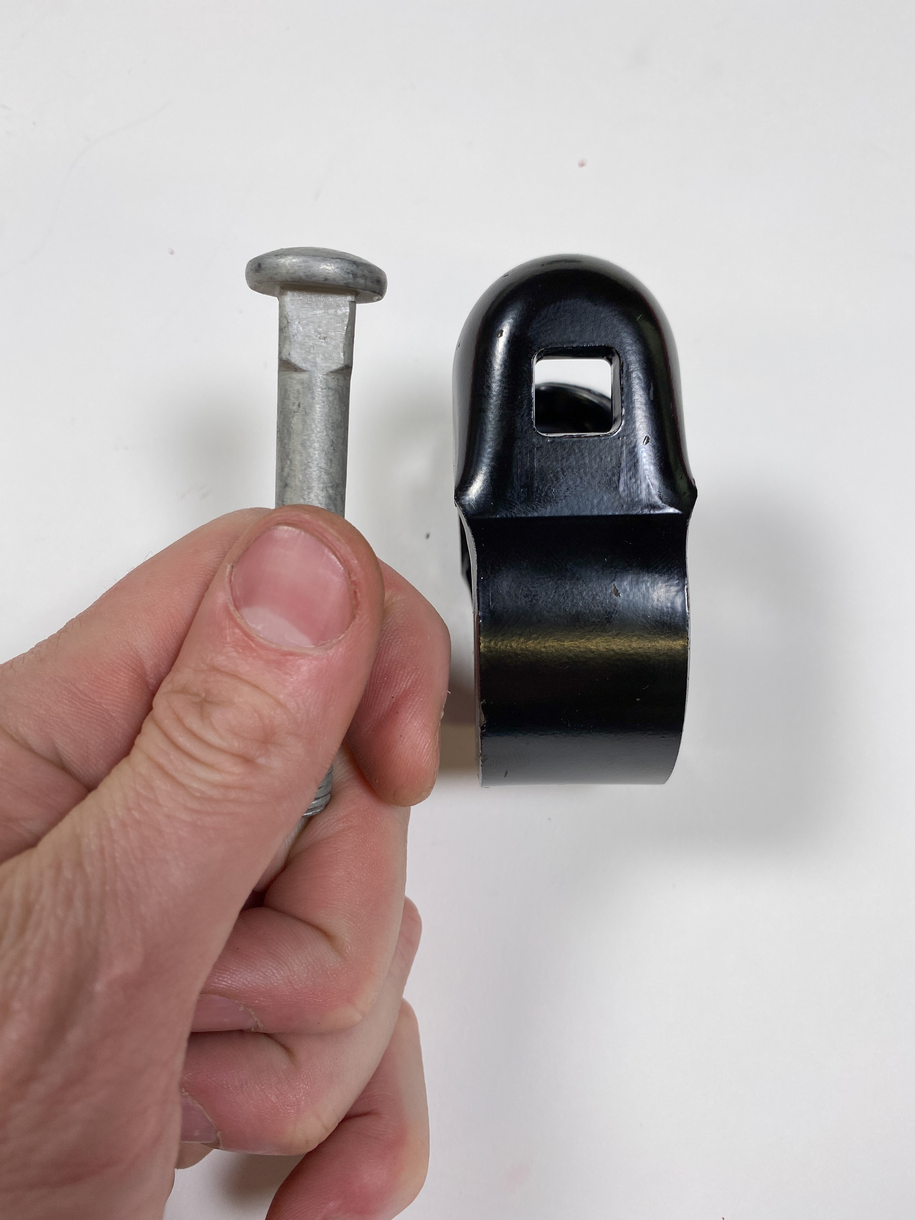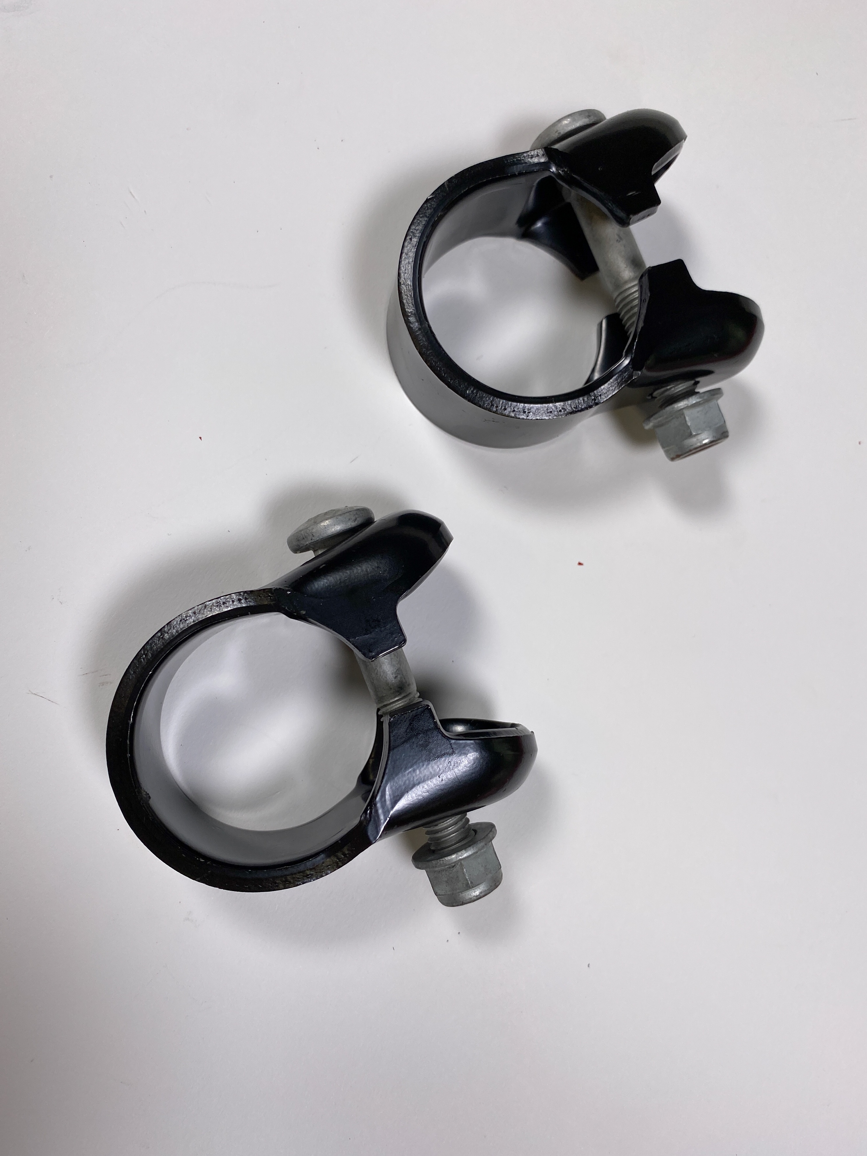
  - Slide the clamps onto the adjuster tube (preferably with the clamps nut facing the same direction), and then snug the nut up so that it still rotates but does not slide off using your 15mm socket or wrench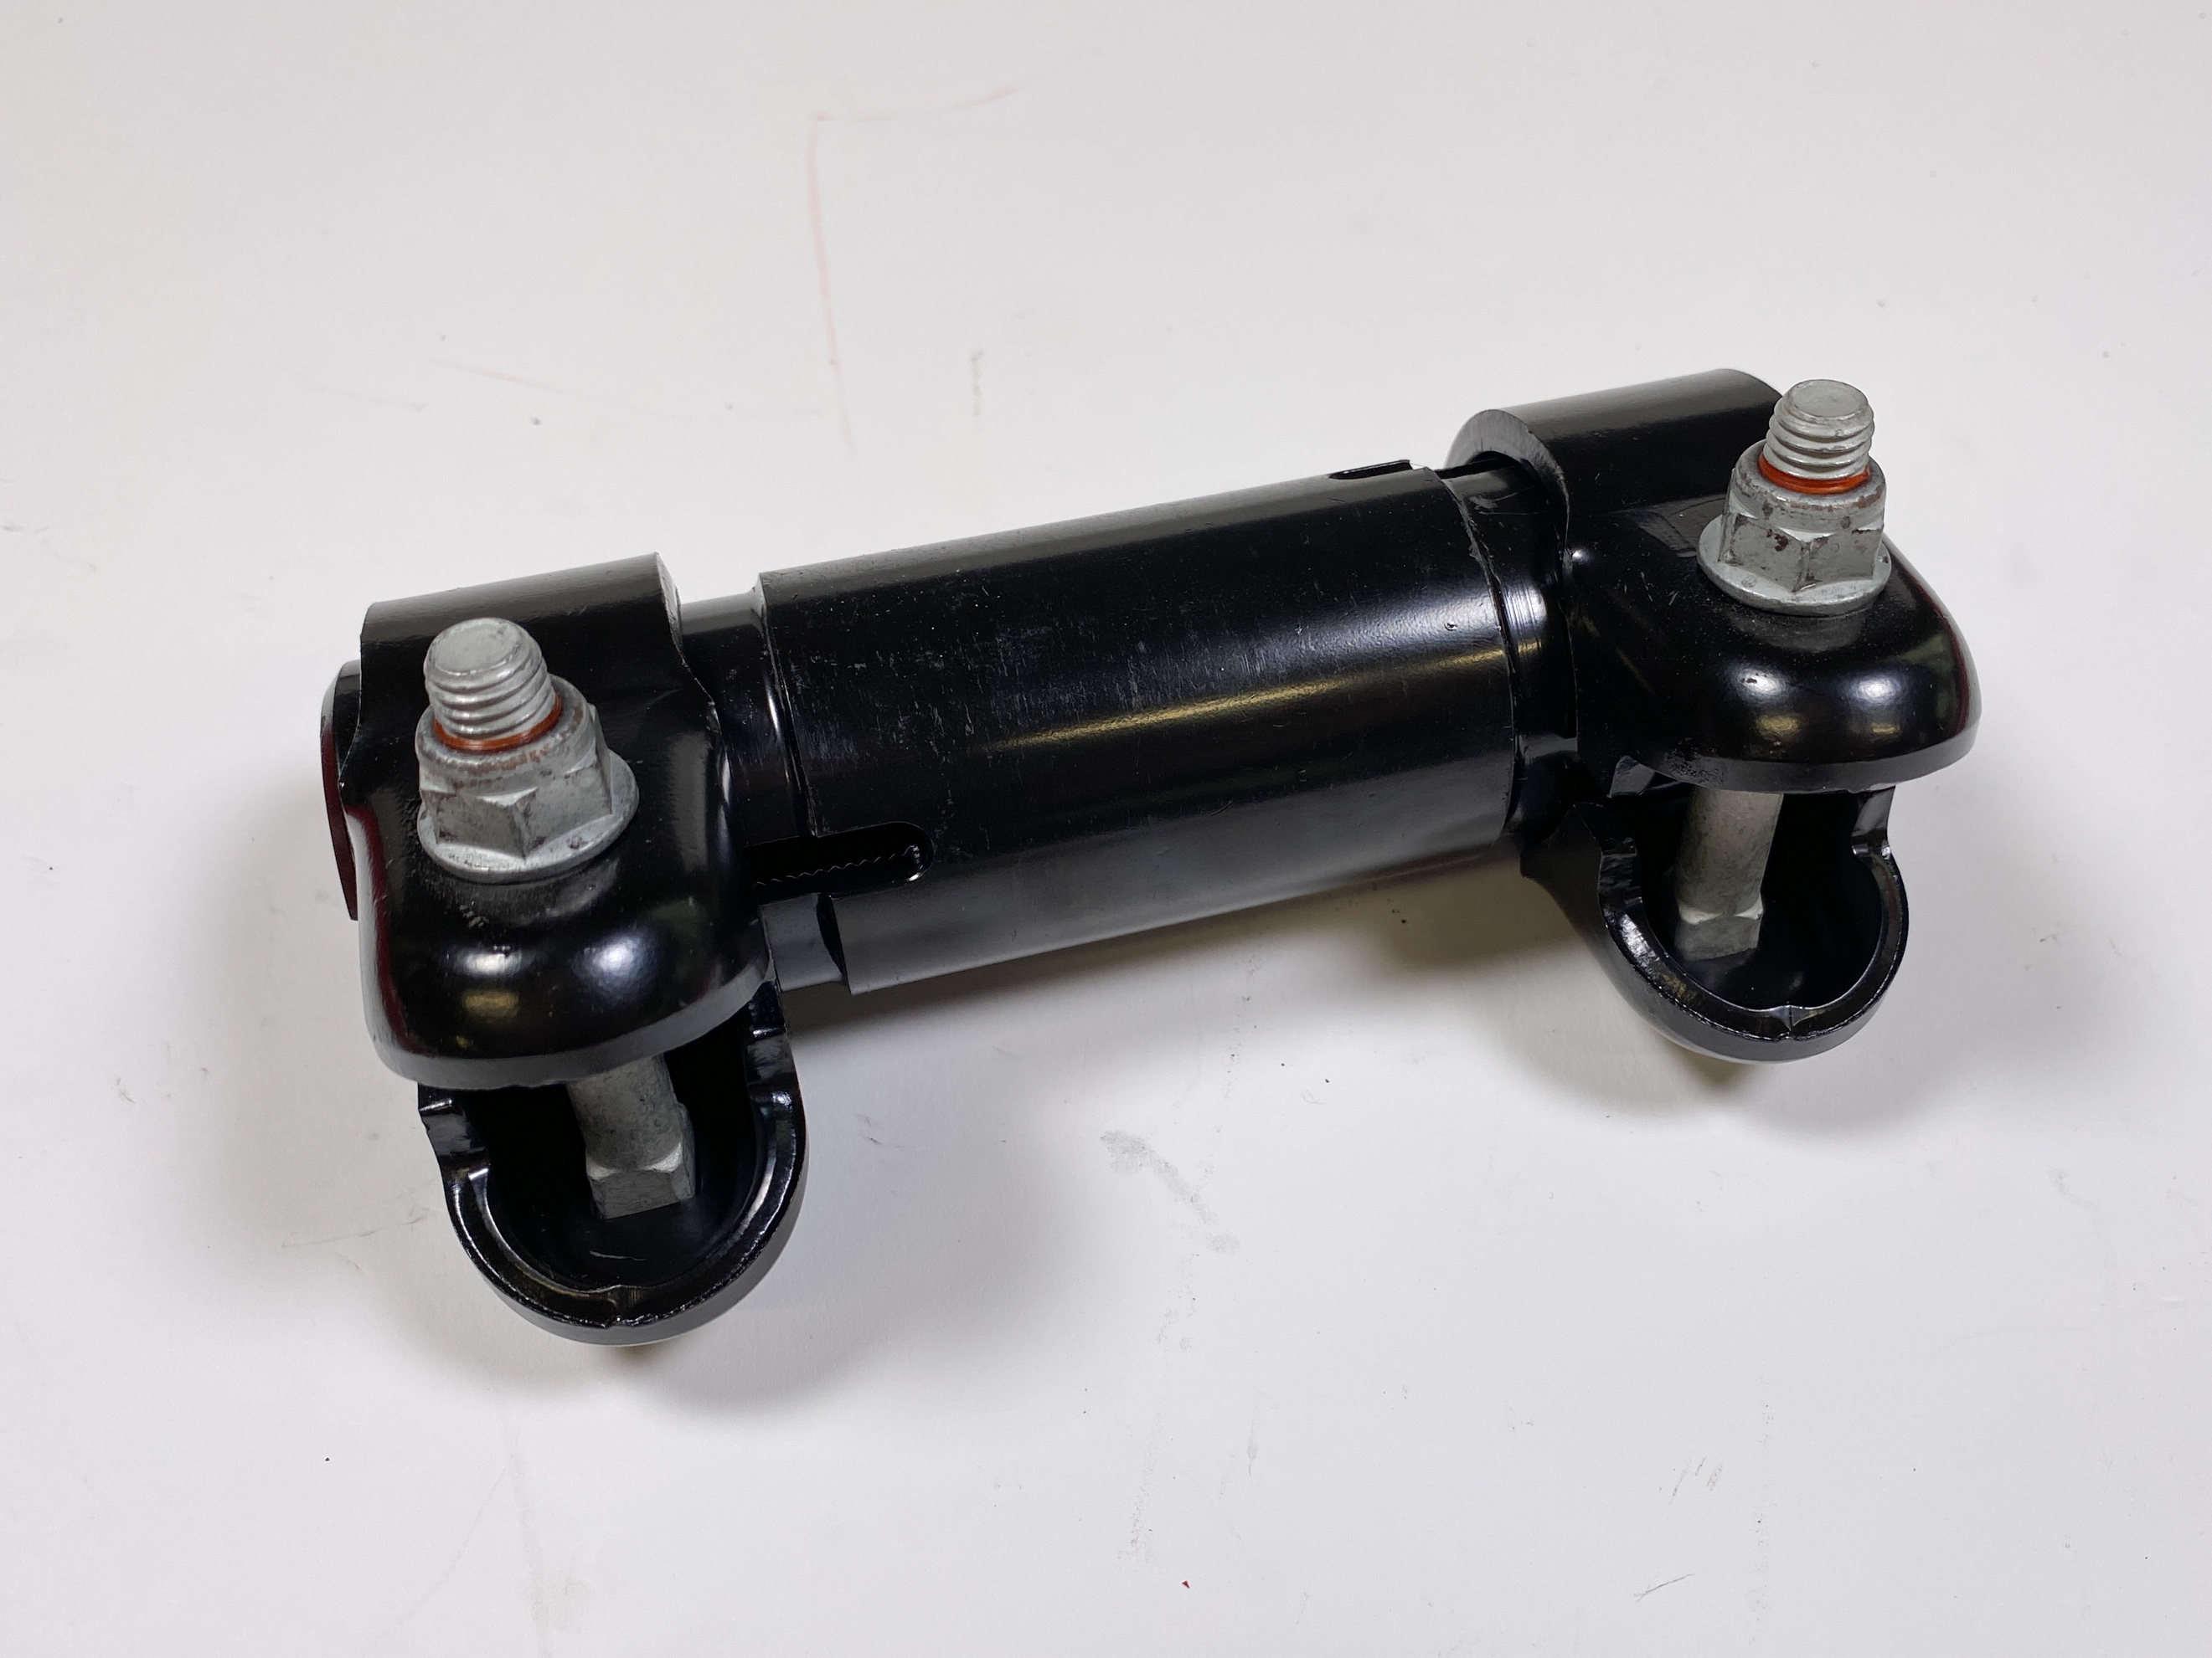
  - Recommended at this point that you apply anti-seize to the threads of each end

  - Note – the ends have different threads. One is standard thread and one is reverse thread, meaning you will spin in one end in clockwise and the other end will go in counterclockwise. This also means that the ends only go in one end of the adjuster. Pay attention to the tube and you will see there are bevels on each end. On one side, you will notice there is a channel/split in the bevel. That end gets the long track bar end and spins counterclockwise. The short end goes on the bevel side without the channel and is a right-hand thread that spins in clockwise.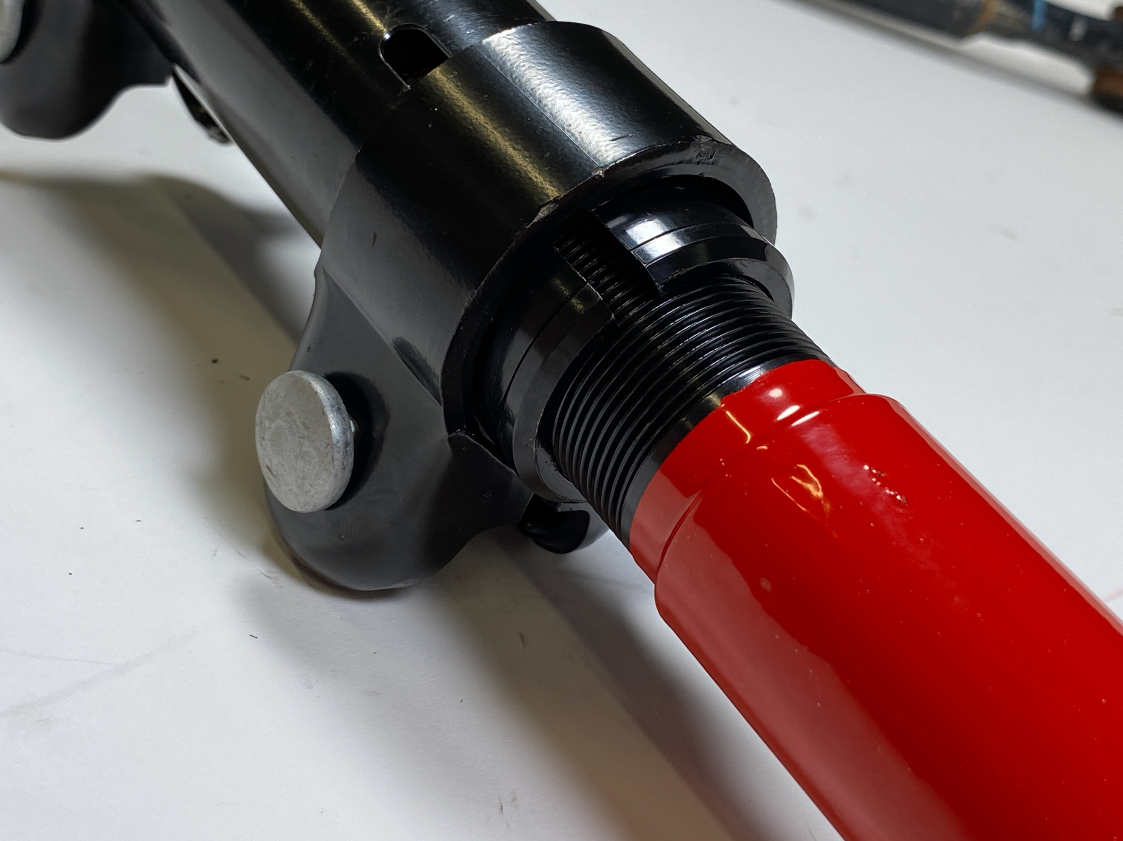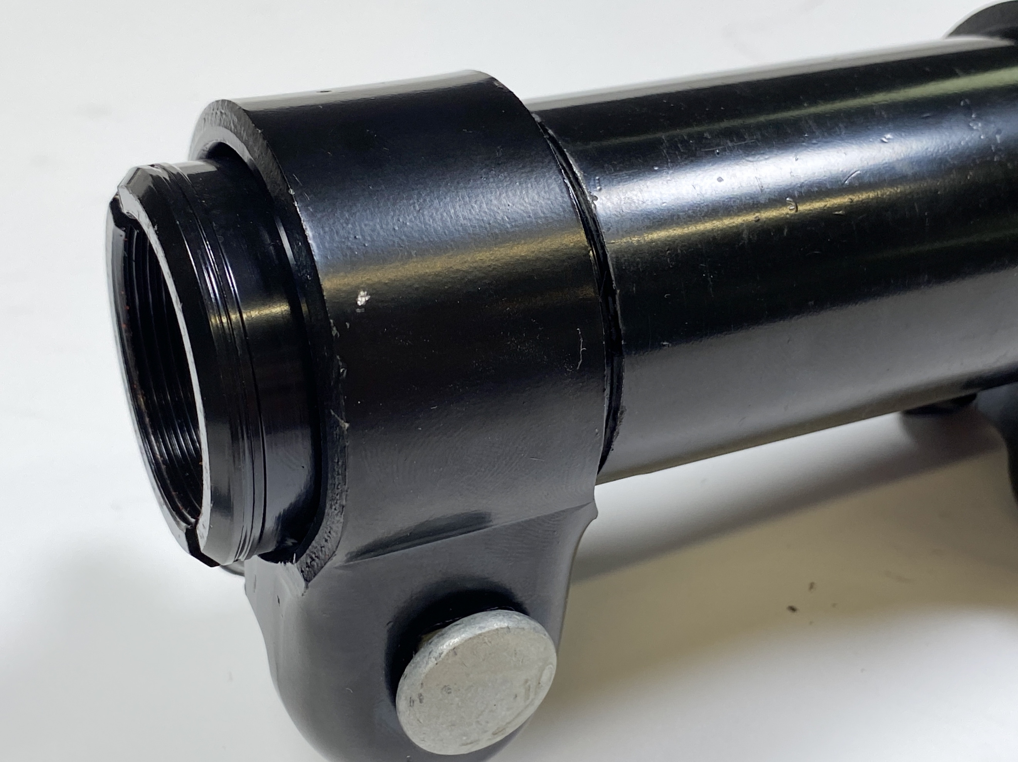
  - Once you have measured the correct length and assembled the track bar, this is the correct installation orientation: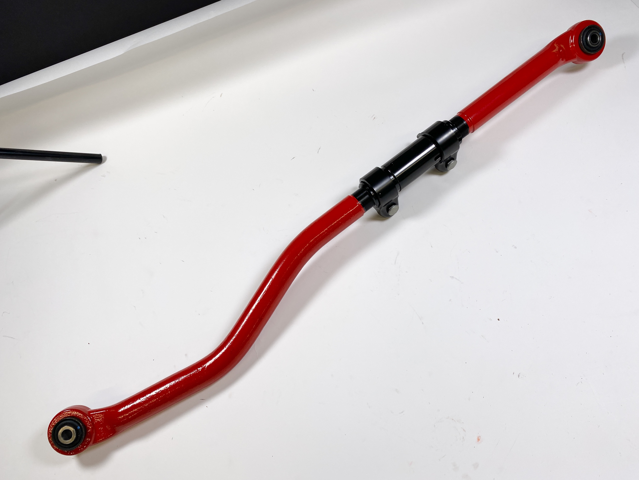

- With the clamps still loose, it is time to install our track bar into the vehicle. Start by putting the passenger side end in and reuse the original 21mm fastener and nut – spin the nut on to hold in place but do not tighten yet.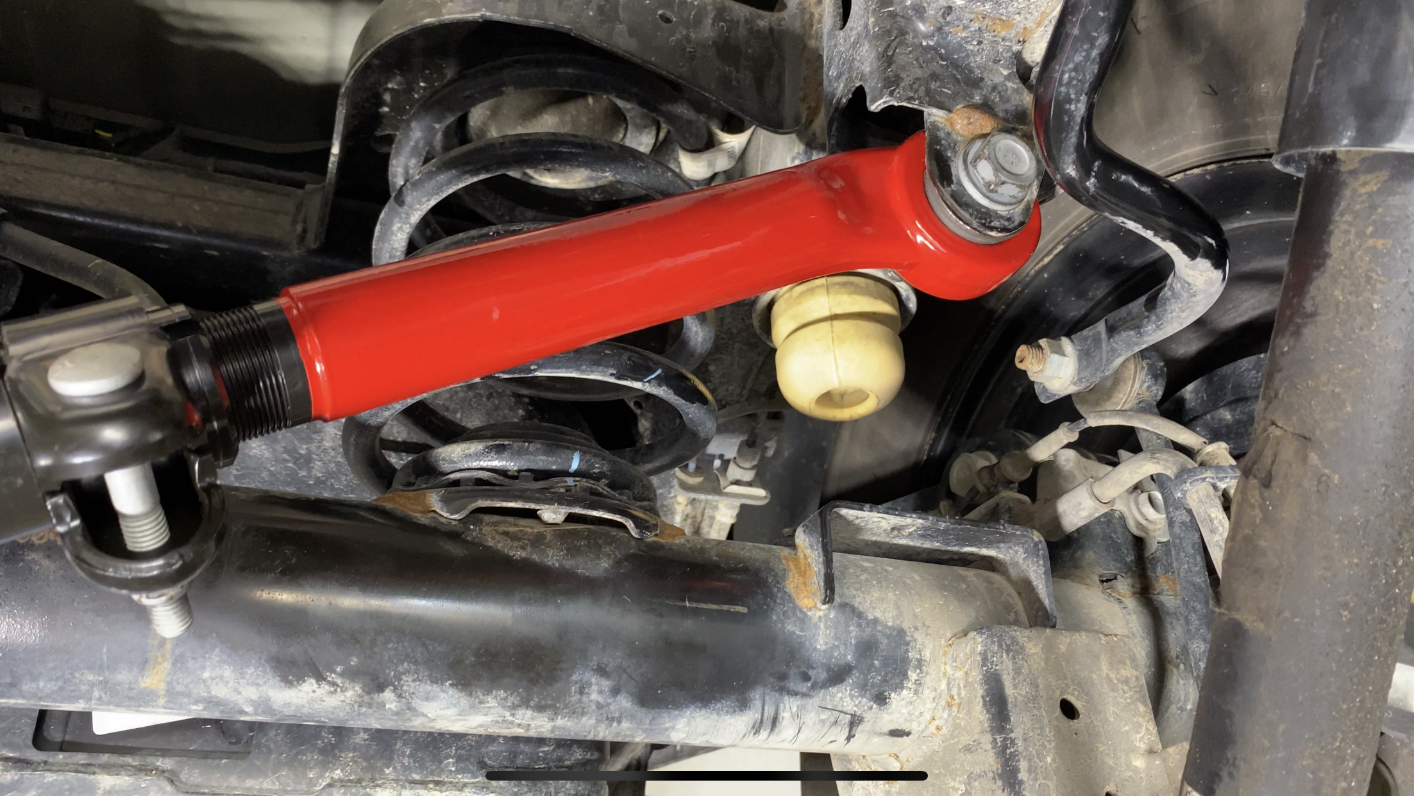
  - At this point you can check clearances on your clamps by sliding the other end into place and rotating them until they look to clear everything with ease. Once you’ve done this and confirmed that the track bar is the right length and you can get the driver’s side fastener through, you can now use your 15mm socket and torque wrench to torque the clamps down to 45 ft lbs
  - You can now put the driver’s side end into the bracket and reinstall the 21mm socket and nut. Now is a good time to double check your clearances.
  - Once confirmed, you can now torque the track bar bolts back down to OEM Spec:
    - Axle (passenger) Side Torque: 74ft lbs + 30˚
    - Frame (driver) Side Torque: 74 ft lbs + 60˚
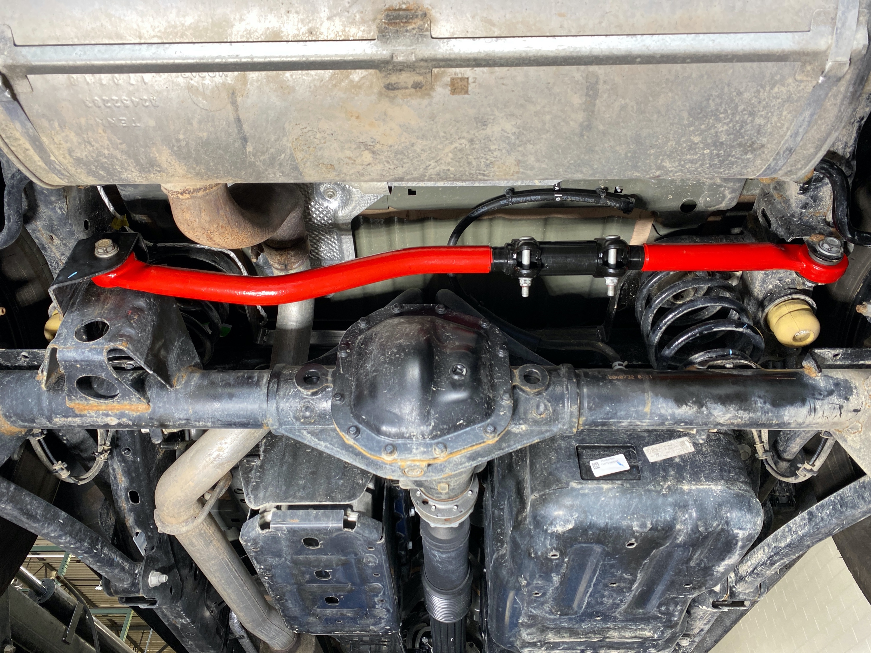

- Re-check torque after 1000 miles, Oil changes, and hard wheeling adventures. Enjoy!

